Below is the code for the ESP32:

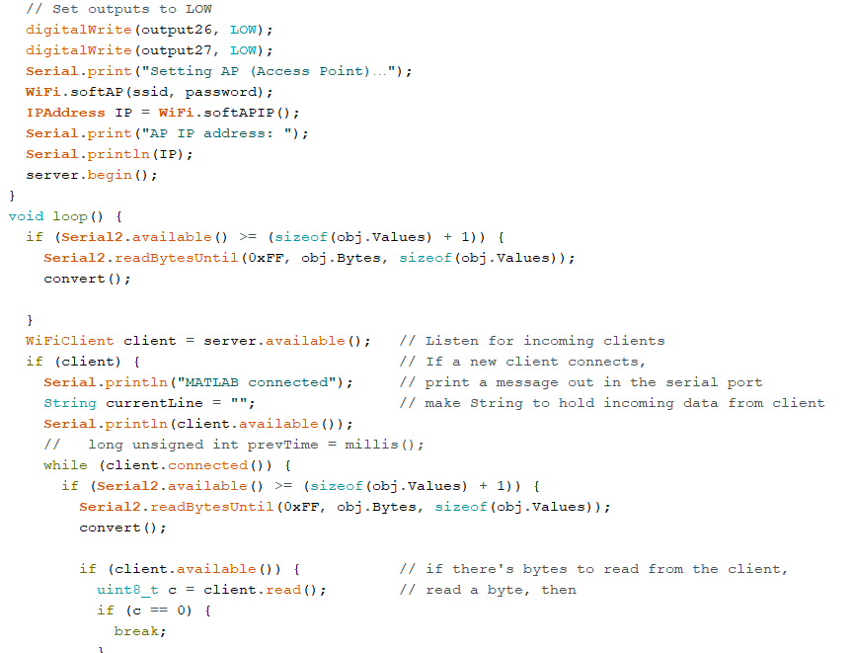

Below is the code in Arduino:

